**GZ1GPS31L-XXX**

**1.25Gbps SFP 1310nm 10~60km Transceivers**

# Features：

* Up to 1.25Gbps data rate
* Duplex LC receptacle optical interface compliant
* Single +3.3V power supply
* Hot-pluggable
* Receiver Loss of Signal Output
* Serial ID module on MOD(0-2)
* International Class 1 laser safety certified
* Transmitter disable input
* Optional operating temperature range: 0~+70℃/-40~85℃
* Optional 10/15/20/40 transmission distance on 9/125um SMF
* 1310nm FP laser for 10/15/20km, 1310nm DFB laser for 40/60km
* ROHS Compliant

# Applications：

* Gigabit Ethernet
* SDH
* Switched backplane applications

# Standard:

* Compliant with SFP MSA (INF-8074i)
* Compliant with SFF-8472 v12.2
* Compliant with IEEE802.3z Gigabit Ethernet

# Absolute Maximum Ratings

|  |  |  |  |  |
| --- | --- | --- | --- | --- |
| **Parameter** | **Symbol** | **Unit** | **Min** | **Max** |
| Storage Temperature Range | Tstg | °C | -40 | +85 |
| Relative Humidity | RH | % | 5 | 95 |
| Power supply Voltage | Vcc | V | -0.5 | 4 |

# Recommended Operating Conditions

|  |  |  |  |  |  |  |
| --- | --- | --- | --- | --- | --- | --- |
| **Parameter** | **Symbol** | **Unit** | **Min** | **Typ.** | **Max** | **Note** |
| Case Operating Temperature Range | Tc | °C | 0 |  | 70 | C-Temp |
| -40 |  | 85 | I-Temp |
| Power Supply Voltage | Vcc | V | 3.135 | 3.3 | 3.465 |  |
| Data Rate | - | Gb/s | - | 1.25 | - |  |

# Specifications (Tc=25℃, BOL, unless otherwise noted)

|  |  |  |  |  |  |  |  |  |  |  |
| --- | --- | --- | --- | --- | --- | --- | --- | --- | --- | --- |
| **Parameter** | **Symbol** | **Unit** | | | **Min** | | **Typ** | **Max** | **Notes** | |
| Electrical Characteristics | | | | | | | | | | |
| Supply Current | Icc | mA | | | - | | - | 300 |  | |
| Single Ended Data Input Swing | - | mV | | | - | | - | 1100 |  | |
| Single Ended Data Output Swing | - | mV | | | 300 | | - | 600 |  | |
| TX_fault /LOS output (TTL) | VOH | V | | | 2.0 | |  | Vcc |  | |
| VOL | 0 | |  | 0.8 |  | |
| TX_disable input (TTL) | VOH | V | | | 2.0 | |  | Vcc |  | |
| VOL | 0 | |  | 0.8 |  | |
| Optical transmitter Characteristics | | | | | | | | | | |
| Launch Optical Power | Po | | dBm | -9 | |  | | -3 | | 10~20km |
| -5 | |  | | 0 | | 40km |
| -2 | |  | | +3 | | 60km |
| Center Wavelength | λc | | nm | 1260 | | 1310 | | 1360 | | FP LD |
| Spectral Width(RMS) | ∆λ | | nm |  | |  | | 4 | | FP LD |
| Center Wavelength | λc | | nm | 1290 | | 1310 | | 1330 | | DFB LD |
| Spectral Width(20dB) | ∆λ | | nm |  | |  | | 1 | | DFB LD |
| Side Mode Suppression Ratios | SMSR | | dB | 30 | |  | |  | | DFB LD |
| Extinction Ratio | ER | | dB | 8.2 | |  | |  | |  |
| Eye Diagram | Complies with IEEE802.3z eye masks when filtered | | | | | | | | | |
| Pout of OFF transmitter | Poff | | dBm | - | | - | | -40 | |  |
| Optical receiver Characteristics | | | | | | | | | | |
| Center Wavelength Range | λc | | nm | 1260 | |  | | 1620 | |  |
| Receiver Sensitivity 1 | Sen | | dBm |  | |  | | -24 | | 10~40km |
|  | |  | | -28 | | 60km |
| Overload Input Optical Power | Psat | | dBm | -3 | |  | |  | |  |
| LOS De-assert | LosD | | dBm |  | |  | | -30 | |  |
| LOS Assert | LosA | | -38 | |  | |  | |  |
| LOS Hysteresis |  | | dB | 0.5 | |  | | 5 | | 2 |

Notes:

1. Measured with a PRBS 223-1 test pattern, @1.25Gb/s, EX=10dB, BER<10-12
2. The LOS Hysteresis to minimize “chatter” on the output line. In principle, hysteresis alone does not guarantee chatter-free operation

# Monitoring Interface

|  |  |  |  |  |
| --- | --- | --- | --- | --- |
| **Parameter** | **Symbol** | **Spec** | **Units** | **Conditions / Notes** |
| Temperature |  | +/-3℃ | ℃ |  |
| Voltage |  | +/-5% | V |  |
| IBias |  | +/-10% | mA |  |
| Rx power |  | +/-3 | dBm | @25℃ |
| Tx power |  | +/-3 | dBm | @25℃ |

**Pin Assignment**

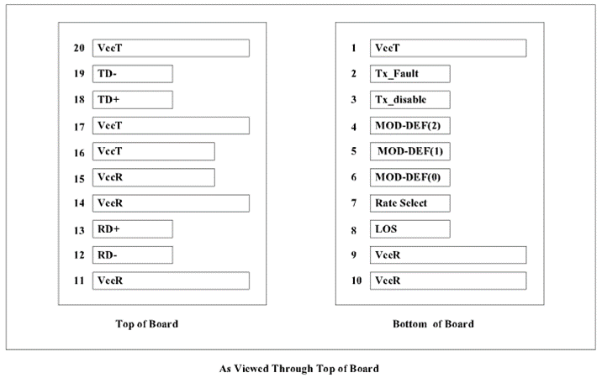

**Pin Description**

|  |  |  |  |  |
| --- | --- | --- | --- | --- |
| **Pin** | **Name** | **Function/Description** | **Engagement order** | **Notes** |
| 1 | VeeT | Transmitter Ground | 1 |  |
| 2 | TX Fault | Transmitter Fault Indication | 3 | 1 |
| 3 | TX Disable | Transmitter Disable-Module disables on high or open | 3 | 2 |
| 4 | MOD_DEF2 | Module Definition 2-Two wire serial ID interface | 3 | 3 |
| 5 | MOD_DEF1 | Module Definition 1-Two wire serial ID interface | 3 | 3 |
| 6 | MOD_DEF0 | Module Definition 0-Two wire serial ID interface | 3 | 3 |
| 7 | Rate Select | Not Connected | 3 |  |
| 8 | LOS | Loss of Signal | 3 | 4 |
| 9 | VeeR | Receiver Ground | 1 |  |
| 10 | VeeR | Receiver Ground | 1 |  |
| 11 | VeeR | Receiver Ground | 1 |  |
| 12 | RD- | Inverse Received Data out | 3 | 5 |
| 13 | RD+ | Received Data out | 3 | 5 |
| 14 | VeeR | Receiver Ground | 1 |  |
| 15 | VccR | Receiver Power —— +3.3V±5% | 2 | 6 |
| 16 | VccT | Transmitter Power —— +3.3 V±5% | 2 | 6 |
| 17 | VeeT | Transmitter Ground | 1 |  |
| 18 | TD+ | Transmitter Data In | 3 | 7 |
| 19 | TD- | Inverse Transmitter Data In | 3 | 7 |
| 20 | VeeT | Transmitter Ground | 1 |  |

Notes：

1. TX Fault is open collector/drain output which should be pulled up externally with a 4.7K -10KΩresistor on the host board to supply <VccT+0.3V or VccR+0.3V. When high, this output indicates a laser fault of some kind. Low indicates normal operation. In the low state, the output will be pulled to <0.8V.
2. TX Disable input is used to shut down the laser output per the state table below. It is pulled up within the module with a 4.7-10K resistor.

Low (0-0.8V): Transmitter on

Between (0.8V and 2V): Undefined

High (2.0-VccT): Transmitter Disabled

Open : Transmitter Disabled

1. Mod-Def 0, 1, 2. These are the module definition pins. They should be pulled up with a 4.7 -10K resistor on the host board to supply less than VccT+0.3V or VccR+0.3V.

Mod-Def 0 is grounded by the module to indicate that the module is present.

Mod-Def 1 is clock line of two wire serial interface for optional serial ID.

Mod-Def 2 is data line of two wire serial interface for optional serial ID.

1. LOS (Loss of signal) is an open collector/drain output which should be pulled up externally with a 4.7-10K resistor on the host board to supply <VccT+0.3V or VccR+0.3V. When high, this output indicates the received optical power is below the worst case receiver sensitivity (as defined by the standard in use). Low indicates normal operation. In the low state, the output will be pulled to <0.8V.
2. RD-/+: These are the differential receiver outputs. They are AC coupled 100Ω differential lines which should be terminated with 100Ω differential at the user SERDES. The AC coupling is done inside the module and thus not required on the host board.
3. VccR and VccT are the receiver and transmitter power supplies. They are defined as 3.3V±5% at the SFP connector pin. The in-rush current will typically be no more than 30Ma above steady state supply current after 500ns.
4. TD-/+: These are the differential transmitter inputs. They are AC coupled differential lines with 100Ω differential termination inside the module. The AC coupling is done inside the module and is thus not required on host board

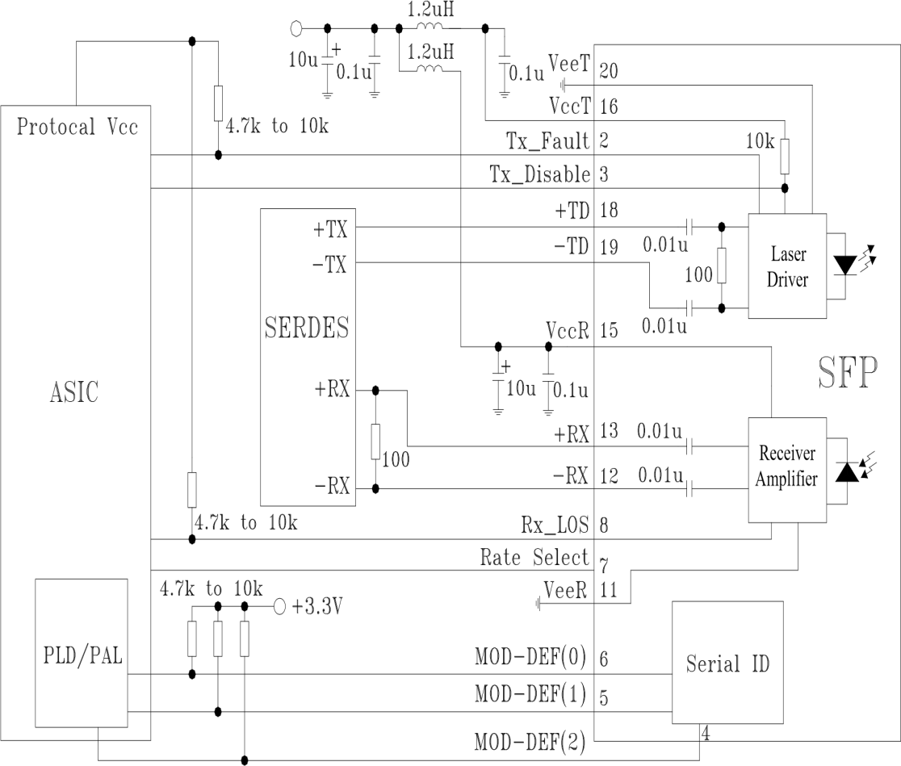**Typical Application Circuit**

# Mechanical Dimensions

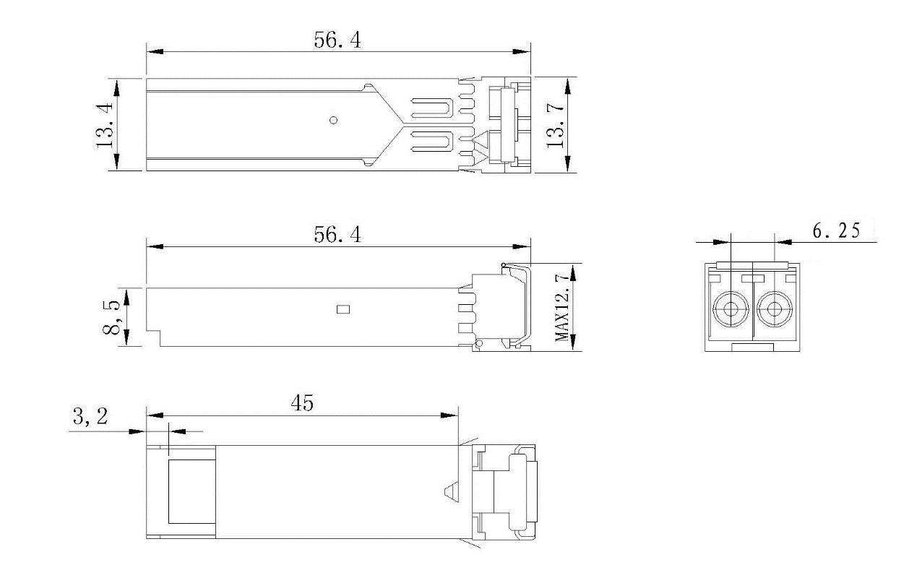

Notes:

1. Tolerance: +/-0.1mm.
2. Others are according with SFF-8074i/SFF-8432 MSA or customer SPEC.
3. Light port according with fiber connector SPEC.

# Ordering Information

|  |  |  |  |  |  |  |  |  |  |
| --- | --- | --- | --- | --- | --- | --- | --- | --- | --- |
| **Part. No** | **Specifications** | | | | | | | | |
| **Rate**  **Gb/s** | **Tx** | **Tx WL**  **nm** | **Po**  **dBm** | **Rx** | **Sen.**  **dBm** | **Temp**  **℃** | **Reach**  **km** | **Other** |
| GZ1GPS31L-10 | 1.25 | FP LD | 1310 | -9 ~ -3 | PIN/TIA | <-24 | 0~70 | 10 | RoHS |
| GZ1GPS31L-15 | 1.25 | FP LD | 1310 | -9 ~ -3 | PIN/TIA | <-24 | 0~70 | 15 | RoHS |
| GZ1GPS31L-20 | 1.25 | FP LD | 1310 | -9 ~ -3 | PIN/TIA | <-24 | 0~70 | 20 | RoHS |
| GZ1GPS31L-40 | 1.25 | DFB LD | 1310 | -5 ~ 0 | PIN/TIA | <-24 | 0~70 | 40 | RoHS |
| GZ1GPS31L-60 | 1.25 | DFB LD | 1310 | -2 ~ +3 | PIN/TIA | <-28 | 0~70 | 60 | RoHS |
| GZ1GPS31L-10I | 1.25 | FP LD | 1310 | -9 ~ -3 | PIN/TIA | <-24 | -40~85 | 10  RoHS | RoHS |
| GZ1GPS31L-15I | 1.25 | FP LD | 1310 | -9 ~ -3 | PIN/TIA | <-24 | -40~85 | 15 | RoHS |
| GZ1GPS31L-20I | 1.25 | FP LD | 1310 | -9 ~ -3 | PIN/TIA | <-24 | -40~85 | 20 | RoHS |
| GZ1GPS31L-40I | 1.25 | DFB LD | 1310 | -5 ~ 0 | PIN/TIA | <-24 | -40~85 | 40 | RoHS |
| GZ1GPS31L-60I | 1.25 | DFB LD | 1310 | -2 ~ +3 | PIN/TIA | <-28 | -40~85 | 60 | RoHS |

**Warnings**

**Handing Precautions:**

This device is susceptible to damage as a result of electrostatic discharge (ESD). A static free environment is highly recommended. Please follow guidelines according to proper ESD procedures.

**Laser Safety:**

Radiation emitted by laser devices can be dangerous to human eyes. Avoid eye exposure to direct or indirect radiation.

**Notice:**

The information provided on this page contains the product target specifications which are subject to change without notice.